🔷 🔥 INSERTION in Min Heap (Heapify UP)

🔷 Step 0: Start with Min Heap
[5, 10, 60, 50, 20, 70]
Tree:
5 (0)
/ \
10 (1) 60 (2)
/ \ /
50 (3) 20 (4) 70 (5)

🔷 Step 1: Insert new element (say 15)
👉 Rule: Insert at end
Array:
[5, 10, 60, 50, 20, 70, 15]

🔷 Tree after insertion
5
/ \
10 60
/ \ / \
50 20 70 15

🔷 Step 2: Heapify UP
👉 Formula:
$$\text{Parent}=\left\lfloor \frac{i-1}{2}\right\rfloor$$

🔹 Current node = 15 (index = 6)
👉 Parent index:
(6-1)/2 = 2 → value = 60

Before
5
/ \
10 60
/ \ / \
50 20 70 15
👉 15 < 60 → swap

After
5
/ \
10 15
/ \ / \
50 20 70 60
Array:
[5, 10, 15, 50, 20, 70, 60]

🔹 Continue Heapify UP
Now index = 2 (value = 15)
👉 Parent:
(2-1)/2 = 0 → value = 5
👉 15 > 5 ✔ stop

🔷 ✅ Final Heap after Insertion
[5, 10, 15, 50, 20, 70, 60]

🔷 🔥 DELETION in Min Heap (Remove Root)

🔷 Step 0: Start Heap
[5, 10, 15, 50, 20, 70, 60]

🔷 Step 1: Remove root (5)
👉 Replace root with last element
Array:
[60, 10, 15, 50, 20, 70]

🔷 Tree after replacement
60
/ \
10 15
/ \ /
50 20 70

🔷 Step 2: Heapify DOWN
👉 Formula:
- Left = 2i + 1
- Right = 2i + 2

🔹 Current node = 60 (index = 0)
Children:
- 10, 15
👉 smallest = 10 → swap

After swap
10
/ \
60 15
/ \ /
50 20 70
Array:
[10, 60, 15, 50, 20, 70]

🔹 Continue Heapify DOWN
Now index = 1 (value = 60)
Children:
- 50, 20
👉 smallest = 20 → swap

Final Tree
10
/ \
20 15
/ \ /
50 60 70
Array:
[10, 20, 15, 50, 60, 70]

🔷 🔥 Final Summary
✅ Insertion
- Insert at end
- Compare with parent
- Swap upward
👉 Heapify UP

✅ Deletion
- Replace root with last element
- Compare with children
- Swap downward
👉 Heapify DOWN

💡 One-line memory
👉 Insert → go UP
👉 Delete → go DOWN

🔷 🔥 MAX HEAP (Only difference)
👉 Rule changes:
✔ Parent ≥ Children
(Everything else same)

🔷 Given Array
[50, 10, 70, 5, 20, 60]

🔷 Initial Tree (using 2i+1, 2i+2)
50 (0)
/ \
10 (1) 70 (2)
/ \ /
5 (3) 20 (4) 60 (5)

🔷 Step 1: i = 2 (value = 70)
👉 Formula:
- Left = 2*2+1 = 5 → 60

Before
50
/ \
10 70
/ \ /
5 20 60
👉 Compare for MAX
👉 70 ≥ 60 ✔ (no swap)

After
50
/ \
10 70
/ \ /
5 20 60
Array:
[50, 10, 70, 5, 20, 60]

🔷 Step 2: i = 1 (value = 10)
👉 Formula:
- Left = 3 → 5
- Right = 4 → 20

Before
50
/ \
10 70
/ \ /
5 20 60
👉 largest = 20
👉 10 < 20 → swap

After
50
/ \
20 70
/ \ /
5 10 60
Array:
[50, 20, 70, 5, 10, 60]

🔷 Step 3: i = 0 (value = 50)
👉 Formula:
- Left = 1 → 20
- Right = 2 → 70

Before
50
/ \
20 70
/ \ /
5 10 60
👉 largest = 70
👉 50 < 70 → swap

After (first swap)
70
/ \
20 50
/ \ /
5 10 60
Array:
[70, 20, 50, 5, 10, 60]

🔷 Continue Heapify (IMPORTANT)
Now node = 50 (index 2)
👉 Formula:
- Left = 5 → 60

Before
70
/ \
20 50
/ \ /
5 10 60
👉 largest = 60
👉 50 < 60 → swap

🔷 Final Tree
70
/ \
20 60
/ \ /
5 10 50

🔷 Final Array
[70, 20, 60, 5, 10, 50]

🔷 🔥 INSERTION in Max Heap

🔷 Step 0: Start Heap
[70, 20, 60, 5, 10, 50]

🔷 Step 1: Insert 65
👉 Insert at end
[70, 20, 60, 5, 10, 50, 65]

🔷 Tree
70
/ \
20 60
/ \ / \
5 10 50 65

🔷 Heapify UP
👉 Formula:
Parent = (i-1)/2

Current = 65 (index 6)
Parent = 2 → 60
👉 65 > 60 → swap

After
70
/ \
20 65
/ \ / \
5 10 50 60
Array:
[70, 20, 65, 5, 10, 50, 60]

Continue
Parent = 0 → 70
👉 65 < 70 ✔ stop

🔷 🔥 DELETION in Max Heap

🔷 Step 0
[70, 20, 65, 5, 10, 50, 60]

🔷 Step 1: Remove root
👉 Replace with last
[60, 20, 65, 5, 10, 50]

🔷 Tree
60
/ \
20 65
/ \ /
5 10 50

🔷 Heapify DOWN

Current = 60
Children:
- 20, 65
👉 largest = 65 → swap

After
65
/ \
20 60
/ \ /
5 10 50
Array:
[65, 20, 60, 5, 10, 50]

🔷 Final Result
✔ Max Heap formed

🔥 Final Summary
Operation | Min Heap | Max Heap
Rule | Parent ≤ children | Parent ≥ children
Insert | Go UP if smaller | Go UP if larger
Delete | Go DOWN (smallest) | Go DOWN (largest)

💡 One-line memory
👉 Min Heap → smallest on top
👉 Max Heap → largest on top

🔷 Two Types of Heapify (you already learned both)

🔹 1. Heapify DOWN (Most Important)
👉 Used in:
- Build Heap
- Deletion

🔷 Logic
👉 Start from a node → go DOWN
Steps:
- Find left = 2i + 1
- Find right = 2i + 2
- Compare with children
- Swap with:
  - smallest (Min Heap)
  - largest (Max Heap)
- Continue downward

🔷 You already did this here 👇
✔ While building heap
✔ While deleting root
👉 That is heapify DOWN

🔹 2. Heapify UP
👉 Used in:
- Insertion

🔷 Logic
👉 Start from last node → go UP
Steps:
- Find parent = (i-1)/2
- Compare with parent
- Swap if needed
- Move upward

🔷 You already did this here 👇
✔ When inserting element
👉 That is heapify UP

🔷 🔥 Your Statement
“If we give unsorted elements, PriorityQueue arranges them according to min heap”
✔ Correct — but internally

🔷 1. What actually happens
When you do:
PriorityQueue<Integer> pq = new PriorityQueue<>();
pq.add(50);
pq.add(10);
pq.add(70);
pq.add(5);
👉 Internally it becomes a Min Heap

🔷 2. Internal Structure (Heap)
It may look like:
5
/ \
10 70
/
50
Array form:
[5, 10, 70, 50]
✔ Smallest element always at top

🔷 3. IMPORTANT: It is NOT fully sorted
👉 If you print directly:
System.out.println(pq);
Output may be:
[5, 10, 70, 50]
❌ Not sorted
✔ Just heap structure

Eg: Priority_Queue
5
/ \
10 70
/ \
50 20

What is Deque?
👉 Deque = Double Ended Queue
That means:
✔ You can insert elements from front
✔ You can insert elements from back
✔ You can remove elements from front
✔ You can remove elements from back
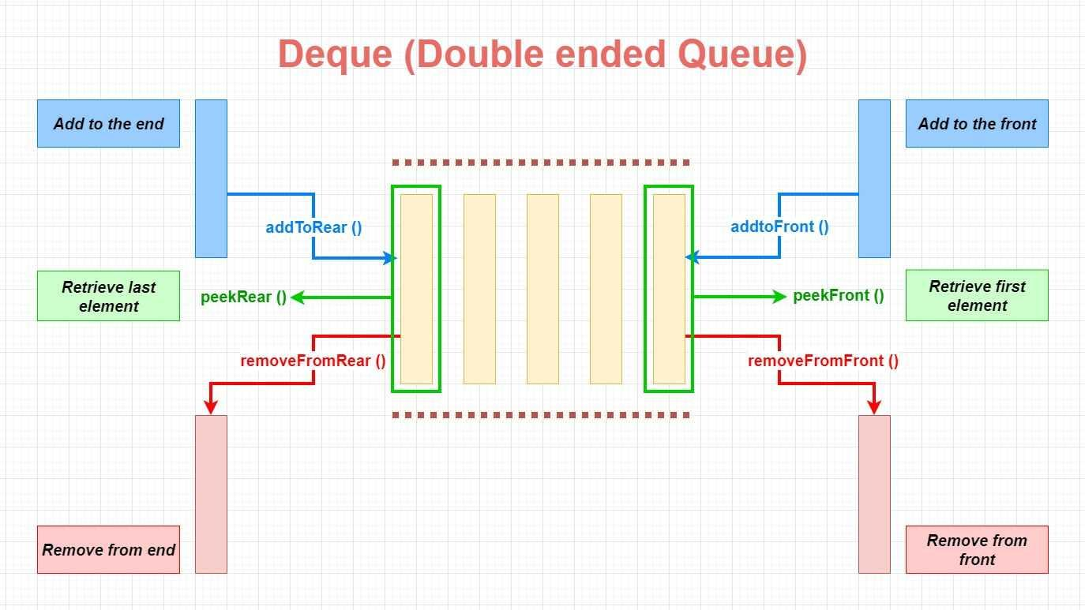
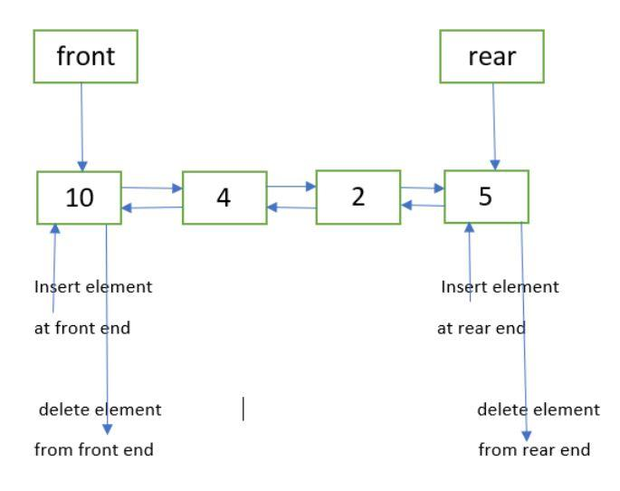
🔹 Java Definition
public interface Deque<E> extends Queue<E>
👉 This means:
- Deque is a child of Queue
- So it supports all Queue operations
- PLUS extra operations for both ends

🔹 Important Implementations
In real projects, mostly used:
- ArrayDeque ✅ (most used, fastest)
- LinkedList ✅ (less used for performance reasons)

